Database Nuggets

This document includes a bunch of explanations, ‘how to’s’ and tips on using a Microsoft Access database.

Record Selector

- This is the gray box on the far-left of each record. By clicking on the record selector, you can select the entire record (for cutting/copying/deleting the record).

- The icons in the record selector give info about that record:
  - = New Record
  - = Current Record
  - = Edit Mode (record is currently being edited)

- To resize a record’s height in datasheet view (‘Excel style’), move your mouse to the bottom edge of the Row Header (gray box at the far-left of the row), click and drag up/down. By increasing a records height, you can allow for multiple lines of text (a.k.a. ‘word wrap).
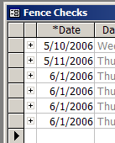

Columns

- To Hide or Show a column in datasheet view (‘Excel style’):

  - Click Format → Unhide Columns…
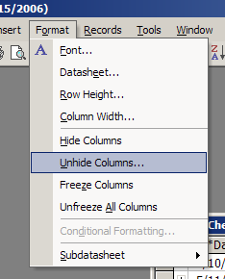

  - In the Unhide Columns window, select/unselect the columns you want to show/hide.

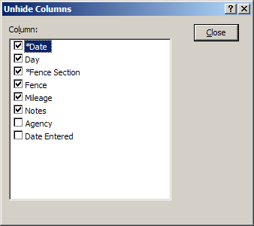

- To resize columns, move your mouse to the right edge of the Column Header (gray box at the top of the column w/ the field name in it), click and drag to the left/right. Double-click to ‘auto-resize’ the column to fit all the text on the screen.
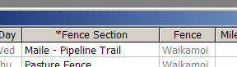

- Zoom: for Notes fields w/ a lot of text, click in the field & hit Shift+F2 to open the Zoom Window. You can view/edit the text in the box.
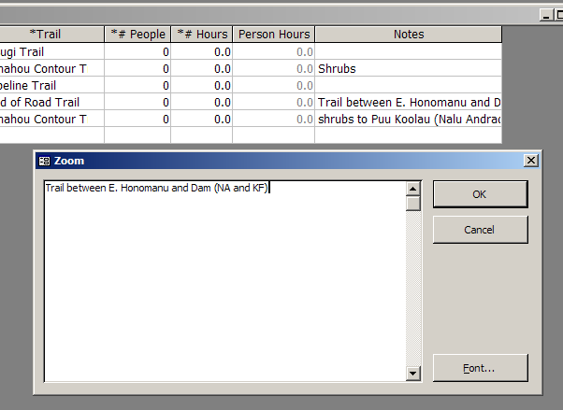

Form Selector

- This is the gray box (available only in datasheet view) at the top left of a form or sub-section. By clicking on the form selector, you can select ALL the records in the form or sub-section.
Form Selector for the Main form
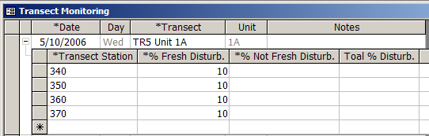
Form Selector for the sub-section

If you click the Form Selector, all the records below get selected:
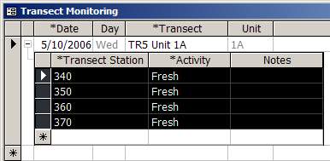
…selected records

…once these records are selected, you can cut/copy/delete them all at one time.

Data Entry

- Using the keyboard is MUCH faster for data entry. Therefore, learn how to navigate/edit w/ the keyboard.
  - Tab or Enter will move you to the next field (to the right).
  - Shift + Tab will move you to previous field (to the left).
  - Ctl+X = Cut
  - Ctl+C = Copy
  - Ctl+V = Paste
  - Esc (once) = Undo changes to current field.
  - Esc (twice) = Undo changes to current record.
  - Ctl+’ = Duplicate value from field in above record.

- Saving data: as soon as you move off of a record, the database saves your changes. There is no ‘Save’ button in databases; they ‘save as you go’.

- A database allways provides one blank line for a new record to be added () at the bottom of the list of records.

- To refresh a drop-down list, click in the field and press F9. Use this if you recently added a new value to a lookup table and it is NOT showing up in the list.

- Record-level locking: A database allows multiple users to use (add/edit/delete records) the database simultaneously. Microsoft Access locks the data at the record level; in other words, it keeps track of which user is editing which record and does NOT allow other users to edit that record until it is saved…however, all other records are available for editing. This is in contrast to Microsoft Excel which uses ‘File-level’ locking. This, as the name suggests, locks the entire Excel document from being edited while it is open; thus, it can only be viewed in a read-only mode.
Dates

- To enter today’s date, press Ctl + ;.

- To enter a date in this year, leave out the year (Access will fill it in the rest).
Ex. Type “5/8” and press Tab or Enter; Access will convert it to “5/8/2006”.

- When entering the year, use the last 2 digits (Access will convert it to it’s 4-digit format).

Times

- Access uses ‘short hand’ for Time fields. It may be confusing at first but can be a time-saver what you learn how to use it:
  - Replace the colon with a period (Access will convert it to a colon).
  - Replace “AM” or “PM” w/ “a” or p” respectively (Access will convert it for you).
  - Ex. To enter “9:35 AM”, type “9.35a” and press Tab.

Delete Record

- To delete a record, click the record selector for the record and hit the Delete key.

- Another way to delete a record, click the record selector for the record, right-click and select Delete Record.

- You are always asked to confirm the deletion of the record; thus, you always get a second chance.

- Deletes are permanent! Once you click Yes, there is NO undo. Your only recovery option is a backup of the database.

- If the database is in a ‘tree-view’ format (i.e. datasheet view where there is a ‘+’ at the far left of each record, with sub-sections below) you must delete the records in the sub-section BEFORE deleting the record above. In other words, always delete from the bottom to the top. (see image below).

1st Delete subsection records
2nd Delete top record
Sorting

- Overview: Sorting (which works very similarly in Excel) is rearranging records in Ascending/Descending order. Access will sort your records based on the data type in the field you sort on.
  - Text field: sorts alphabetically with the following order
    - Blanks (aka ‘null’ values)
    - Special Characters (ex. !@#$%^&)
    - Numbers
    - Letters (A-Z).
  - Number field: sorts numerically.
  - Date field: sorts chronologically

- How to sort:
- Click on the column header of the column you want to sort.

- On the toolbar, click (ascending) or (descending) to sort.

- You can sort on multiple columns by selecting the multiple columns (i.e. select the column headers) before clicking the sort button. Note: you can only sort on multiple columns if the columns are adjacent to each other. Furthermore, the left-most selected column will sort 1st, then the column to its immediate right, and so on.

Filtering

- Overview: Filtering (which works very similarly in Excel) allows you to query records ‘on the fly’. You can select the criteria you want to filter for and then see only the records that match criteria.

- How to filter:
  - Click in the field that has the value you want to filter on.

  - On the toolbar, click (Filter By Selection). All the records that match that criteria will shown; all those that do NOT will be hidden.

  - You can further filter the records by repeating steps #1 & #2.

Note: the Navigation bar (at the bottom-left of the db window) will let you know how many records were found using the filter as well as if a filter is being applied….

NOT Filtered =

Filtered =

- To remove the filter, on the toolbar, click (Remove Filter).

Excel

- It is very easy to pass data between Access and Excel. A common reason to export from Access to Excel is to work w/ a subset of db data in a more flexible format. A common reason to import from Excel to Access is to enter data into a db that already exists in Excel.

- How to export from Access to Excel:
- Select the db records (or columns) you wish to export.

- Press Ctl+C to copy the records.

- Open an Excel worksheet and click on the cell you wish to paste to.

- Press Ctl+V to paste the records.

Note: the data that has been pasted into Excel is NOT linked to the db. Thus any changes made to the data in Excel will NOT be reflected in the db.

- How to import from Excel to Access:
Before importing, you must make sure the following is in place:

  - The columns in Excel are in the same order (from left to right) as the columns in the db.
  - The db window you are importing into is in datasheet view.
  - The values in Excel are all valid values in the db. (ex. If a value in a column in Excel is NOT in the Lookup Table for the column in the db, you will get a paste error).
  - A blank value in a column will be allowed in the db. (ex. If the corresponding db field is required (i.e. has an asterisks before the field name, the value must be provided).
  - There are no entirely blank rows in Excel.
  - In Excel, the ‘field names’ are NOT in a cell at the top of the column. (ex. Often the name of column in Excel is in Row A. If Row A is imported with the rest of the data, it will appear as ‘data’ in the db and NOT as a ‘field name’/’column header’).
  - Highly Recommended: Make a backup copy of the db (see Backups section below) BEFORE performing this operation (just in case it all goes terribly wrong).

So here is how to import (a.k.a. ‘Paste Append’) from Excel into Access:

- In Excel, select the cells that contain the data. Make sure to ONLY include the cells that have the data and NOT any surrounding blank cells or field/column names.

- Press Ctl+C to copy the cells.

- In the db, open the window you wish to paste into.

- Select the blank row at the bottom of the db window (the ‘new record’ row).

- Press Ctl+V to paste append the data.

- A message will appear saying “You are about to past xx record(s). Are you sure you want to paste these records?”. Click Yes.

Note: If this operation goes smoothly (because you followed all the recommendations above), you are done. However, if you get an error, the message will tell you, if you read it, why it was NOT able to paste some or all of your data. This is usually followed by a couple more messages that are NOT that important until you get to the last message which should be something to the effect of “Records that <db name> was unable to paste have been inserted into a new table called ‘Paste Errors’.” To view these records that did NOT cooperate…

- Click OK to the above mentioned message.

- Press F11 (to view the Access database window).
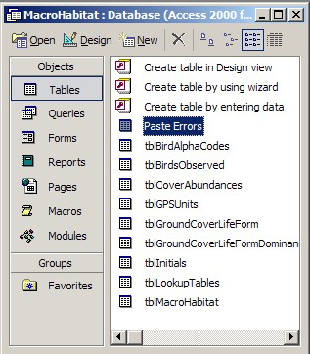

- Along the left-side of the Access database window, click Tables.

- Double-click Paste Errors.
Backups

As mentioned above, deletes are permanent. Thus, a good backup strategy will make recoveries from accidental deletions much easier.

One way to backup a database is a basic file backup procedure. Most networks/servers are backed-up on a regular basis. Talk w/ your Network Administrator to find out: if your database is included in the backup, how often it is backed up and what is the procedure to recover a file if needed.

Another way to backup a database is to simply copy/paste the .mdb file to a Backups folder. Although this is NOT an automated process (like the backup procedure outlined above), this is easier to control. Here is Aaron’s recommendation on how to do it:

- Create a folder named “Backups” in the same location as the database itself. If your db is a Split db (see Stand-alone vs. Split Databases section below), this would be the location of the back end data file.

- Copy the db file and paste it into the Backups folder you created in step #1. If your db is a Split db, copy the back end data file (i.e. “_Data.mdb”).

- Open the Backups folder and locate the file you just pasted.

- Rename the file to include the date it was last updated (a.k.a ‘Date Modified’ in My Computer/Windows Explorer) after the file name.

Ex. To backup the Ungulates_Data.mdb file that was last updated 6/19/2006, rename it to “Ungulates_Data-2006-06-19.mdb”. You can use any date format you want. However, Aaron prefers year-month-day because all of your backups will sort chronologically.

Important Note!: Any time an Access file is opened/closed, regardless whether it was edited or not, the ‘Date Modified’ will be updated to the time it was closed. This is why it is important to put the Date Modified in the backup files name. In other words, you can NOT trust the Date Modified for an Access .mdb file; this is generally NOT the case with any other Microsoft Office document.

Stand-alone vs. Split Databases

A database can exist in one of either of two formats: Stand-alone or split.

Stand-alone databases have both the user-interface (a.k.a. the ‘windows’ you view your data in) and the data (i.e. tables) in one file. This is a simpler format since the entire database is self-contained. However, it is not as ‘multi-user’/network friendly; in other words, although multiple people can open the db as the same time, the db will run slow because it is ‘sharing’ everything, NOT just the data. This format is also less convenient to manage db updates with (more on this in the Database Updates section below). Stand-alone db’s work well when there is only 1 or 2 users using the db at different times.

Split database have the user-interface in one file (a.k.a ‘front end’) and the data in another file (a.k.a ‘back end’). The typical setup with a split database has the back end data file on a server (or any shared folder on a network) and a copy of the front end file on each computer that will be using the db. When a user wants to open the database, they open their copy (on their computer) of the front end file. This db format is MUCH more ‘multi-user’/network friendly because the ONLY thing being shared is the data (and NOT the user interface). This format is more convenient to manage db updates with (see Database Updates section below). Split db’s work well when there are multiple users using the db at the same time.
Typically, the back end data file has the same name as the front end file, only w/ a “_Data” suffix after the database name. Thus, for a db named “Ungulates”, the front end file will be Ungulates.mdb and the back end data file will be Ungulates_Data.mdb.

As mentioned above, the front end file does NOT contain the data; it does, however, contain the user-interface (i.e. Forms, Queries and Reports). The front end file allows the data in the backend file to be viewed. To use an analogy, the front end file is like 3-D glasses you would use at a 3-D movie theatre. The movie screen (i.e. the back end data file) can be viewed simultaneously by each person wearing their own pair of 3-D glasses (i.e. their own copy of the front end file).

The first time a front end file is opened, it must be shown where the back end data file is on your network. This is called ‘relinking the tables’. More on this in the Relinking Tables section below.

Another consideration is the location of the front end file on each computer. Aaron recommends that a folder named “Databases” be created on the C: drive on each computer that will be accessing the db (thus, C:\Databases). This folder can be shared w/ permissions allowing the database administrator (a.k.a. the person Aaron emails the updates to) to view this on all computers over the network. A copy of the front end file can then be put in this folder. More on why Aaron uses this setup:

- C:\Databases is used instead of the My Documents folder because, with Windows XP (and most network setups), the contents of the My Documents folder changes on a single computer based on the user logged onto that computer. Thus, if Kimo saves the front end file to My Documents on Computer1, then Honey Girl logs on, she will NOT see the front end file that Kimo saved. However, C:\Databases can be made available to all users of a particular computer.

- The C:\Databases folder is shared with permissions for the database administrator (db admin) so that when the db admin receives the updated front end file, they can copy the update to all necessary computers without having to walk to each computer. Although this step is NOT necessary, it definitely makes distributing updates much easier.

Database Updates

Database updates include any changes/updates/fixes to any part of the database (user-interface &/or tables). Delivering updates to you, the client, can mean several things depending on what format your db is in (Stand-alone or Split, see Stand-alone vs. Split Databases section above) and what changes were made (user-interface &/or tables).

Stand-alone:
Any changes made to any part of a stand-alone db are handled the same. The client must send the db file to Aaron and then replace the original with updated version Aaron sends back to the client. While Aaron is performing the update, the db can be viewed but should NEVER be edited; any edits made prior to the client receiving the update WILL BE LOST FOREVER AND EVER!

Split:

There are two scenarios for updates depending on where the changes are made in the db: Front end changes only and back end changes.

1. Front end changes only: In this case, the client does NOT need to send anything to Aaron for the update to occur. Furthermore, the client does NOT need to stop working w/ the db. Upon completion of the changes, Aaron will send the updated front end file to the client. The client will copy the updated front end file to each computer and overwrite the original. The front end file must then be relinked to the back end data file (see Relinking Tables section below).

2. Back end changes: Similar to the Stand-alone update situation, the client must send the back end data file to Aaron and then replace the original with updated version Aaron sends back to the client. While Aaron is performing the update, the db can be viewed but should NEVER be edited; any edits made prior to the client receiving the update WILL BE LOST FOREVER AND EVER.

Since front end changes happen more often then back end changes, the impact on the client, with regards to updates, is drastically reduced (as alluded to in the Stand-alone vs. Split Databases section above).

Relinking Tables

This section is for Split db’s ONLY. As mentioned above, anytime a front end file is opened for the 1st time on a computer, it must be shown where the back end data file is on the network. Your db is equipped w/ a Relink Tables utility that automatically detects if it needs to be relinked. Note that this utility can be accessed anytime from Main Menu → More Stuff tab → Relink Tables.

If you open the front end file and see this…
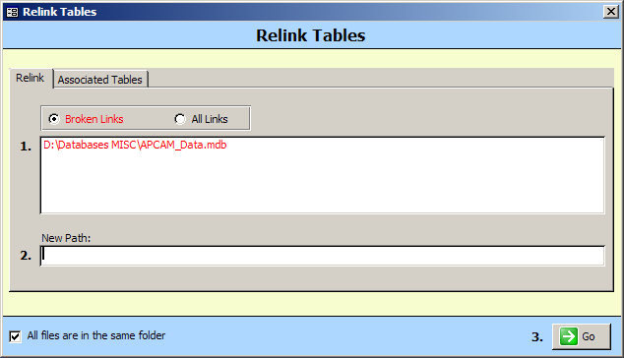

…you probably need to relink your tables.

Here is how to do it (note that each step # below corresponds w/ a # in the Relink Tables window).

- Click on the back end data file (in red) in the box labeled 1..

This will open a file browse window. Navigate to and select the back end data file and click Open.

- The file (& its path) you selected will show up in the New Path: section.

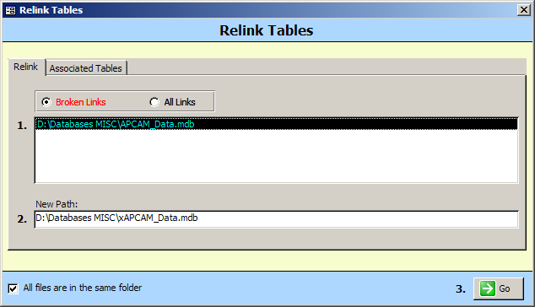

- Click the Go button in the bottom-right corner.

- Click OK to the following message:

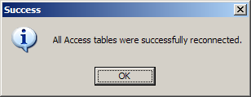

- Close the Relink Tables window and your db should open normally.

~pau~

