Turn Off Macro Security Warnings in Microsoft Access 2010
- Start Microsoft Access 2010 from the Start Menu.

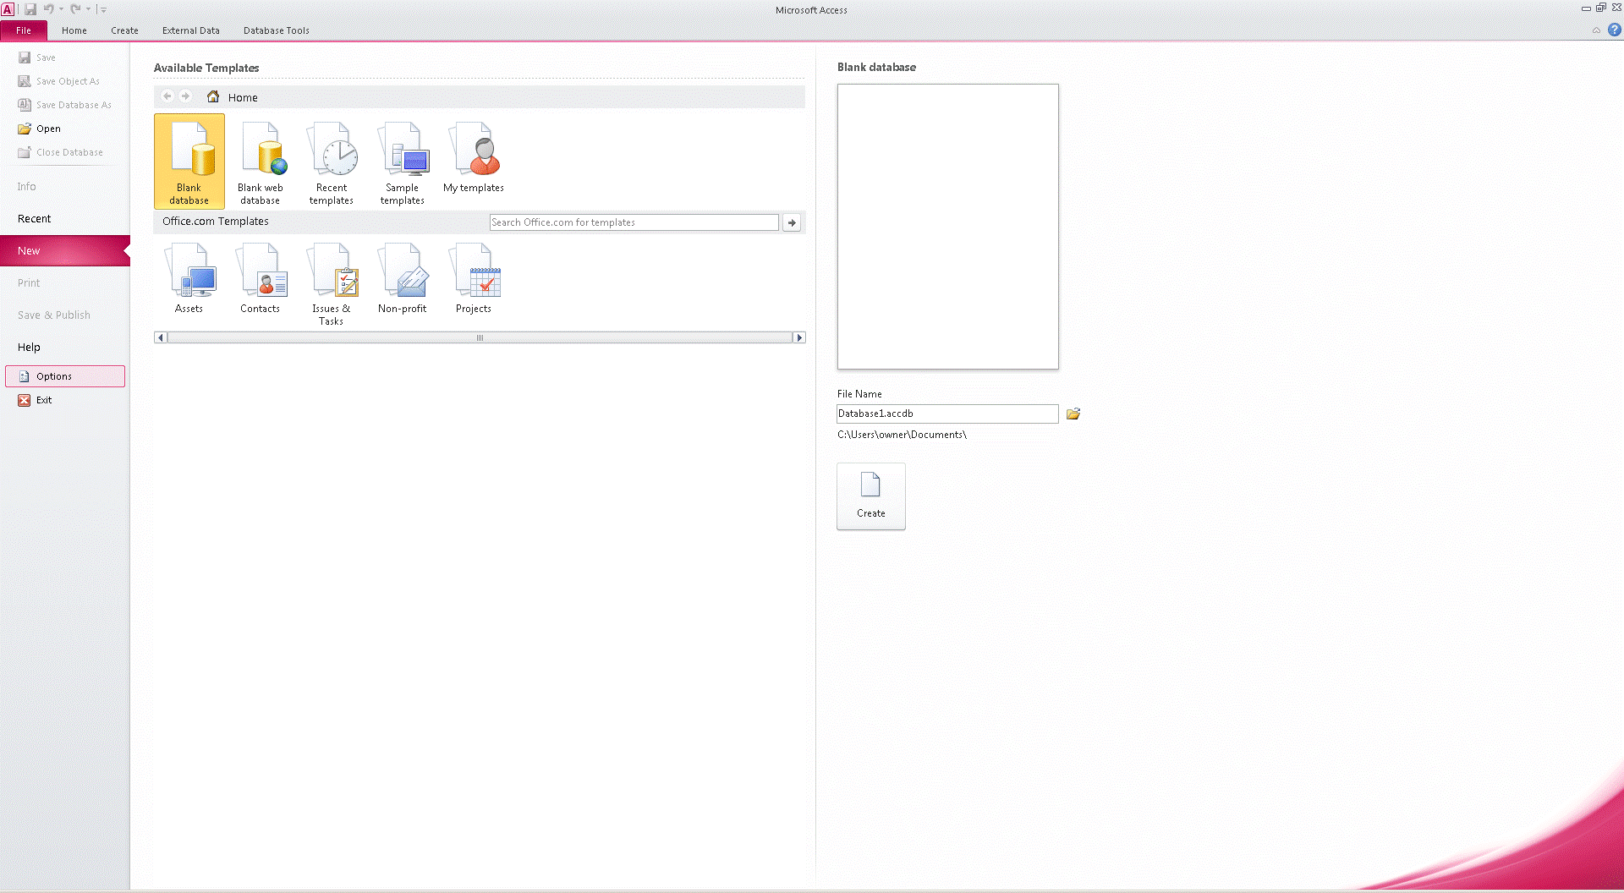
- Click File in the upper left corner of the screen.
- Click Options in the lower left corner of the screen.
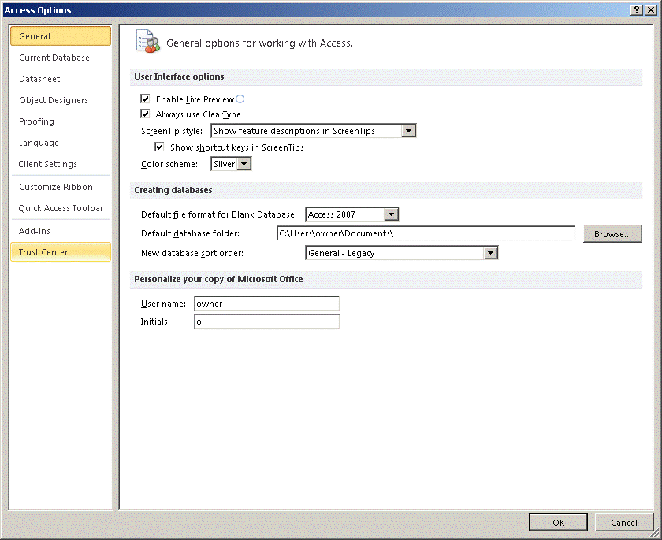
- Click Trust Center on the left side of the screen.
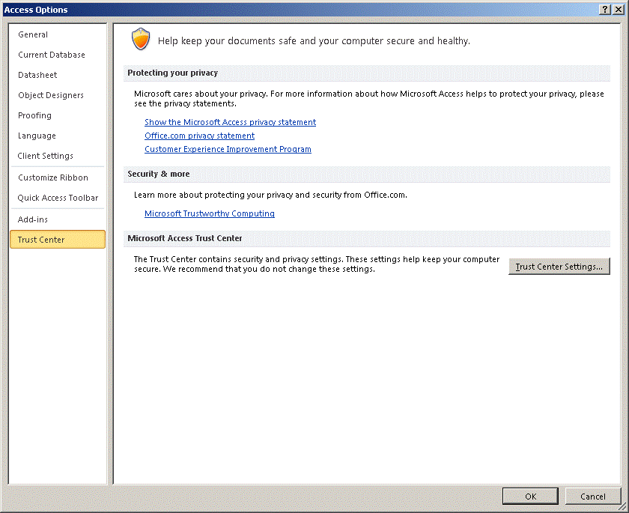
- Click Trust Center Settings halfway down on the right side of the screen.
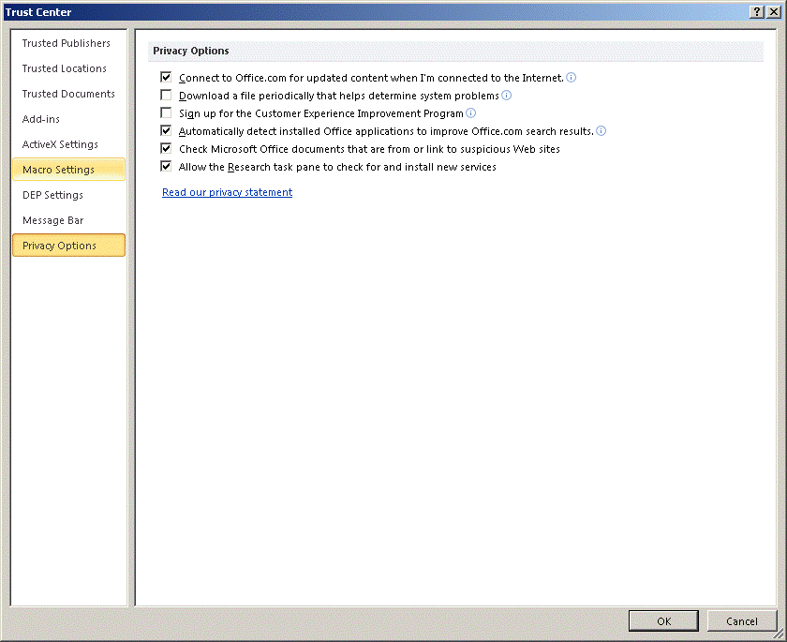
- Click Macro Settings on the left side of the screen.
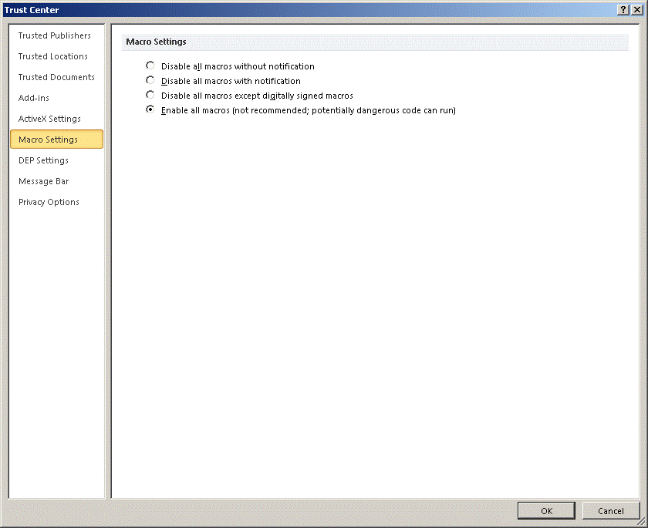
- Select the Enable All Macros option and click OK.

2. Click File in the upper left corner of the screen.
3. Click Options in the lower left corner of the screen.
4. Click Trust Center on the left side of the screen.
5. Click Trust Center Settings halfway down on the right side of the screen.
6. Click Macro Settings on the left side of the screen.
7. Select the Enable All Macros option and click OK.

